INTELLIGEN TRAIN ENGINES TO AVOID ACCIDENTS

ABSTRACT:

Now-a-days public is facing many threats from the railway department by which they are hesitating to plan a train journey. The main reason for this is due to the accidents that occur due to negligence of train drivers. Though the railway department is trying to take actions to reduce such informal things but couldn’t see the face of success. To help out the department we have designed our system.

This project is introduced to monitor driver’s condition and to alert him. The main functionality of this system is to monitor the driver’s action for sometime and if he fails to do any defined action within a specific period, the train will be stopped immediately. Here the driver’s actions can be defined as blowing the horn or applying brake or accelerating the train etc. If the driver fails to do any of the above actions for every 2 minutes, our system gives a siren sound which the driver should switch off with in the defined time, if failed the train will stop immediately.

This system also checks for the stop signal or red light signal irrespective of driver’s action and status and stops the train. In this way by monitoring the common parameters continuously, we have every chance to reduce accidents. For demonstration, we will be providing switches for each parameter so that we can simulate and show the result of our system effectively. Thus we can say that this system proves to be a very useful tool for the railways department to reduce the accidents rate.

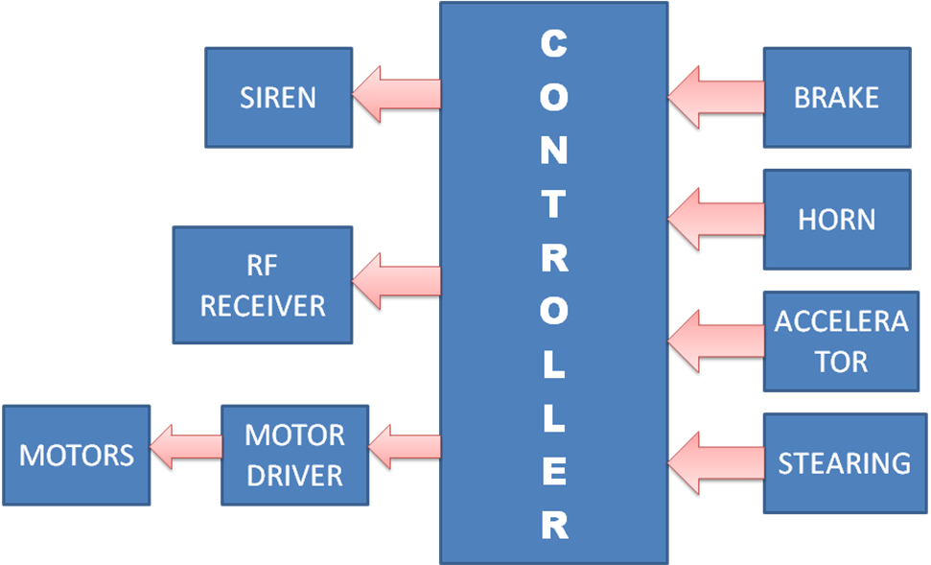
BLOCK DIAGRAM

